Total Marks: _____________

Obtained Marks: _____________

Submission Date: _____________

DIGITAL LOGIC
DESIGN
(DOCUMENT)

REMOTE TESTING CIRCUIT

Submitted To: MR.MUHAMMAD FAROOQ
__________________________________________________________________________

Student Name: NOOR MUHAMMAD AHSAN
__________________________________________________________________________

Reg. Number: 2512341
___________________________________________________________________________

Contents

Introduction.....................................................................3
Abstract............................................................................4
Objectives.........................................................................4
Basic Components...........................................................4
Circuit Diagram...............................................................6
General Principles...........................................................7
Truth Table......................................................................7
Conclusion........................................................................8

Remote Testing Circuit Using Transistor Switching

- Introduction
A Remote Testing Circuit is an electronic system that allows the monitoring and control of a device from a distance using electrical signals. It eliminates the need for direct physical interaction by enabling a user to send input signals that can test or operate a circuit remotely. Such systems are important in applications where accessibility is limited, safety is a concern, or continuous monitoring is required.
This project demonstrates a simple remote testing circuit using basic electronic components such as a transistor, resistors, a diode, and an LED. The circuit operates on the principle of transistor switching, where an input signal controls the flow of current to the output. When the input signal changes, the circuit responds accordingly by turning the LED ON or OFF, indicating the system’s status.

Abstract
This project presents a simple remote testing circuit that uses a switching mechanism based on a PNP transistor to control an LED output. The circuit takes a pulse signal as input and determines whether to turn the LED ON or OFF. By combining basic components such as resistors, a diode, a transistor, and a DC supply, the system demonstrates fundamental concepts of signal control, switching, and protection. This setup is useful for understanding remote triggering, signal conditioning, and transistor based switching circuits.

Objective
- To design and implement a remote controlled LED switching circuit.
- To understand the working of a PNP transistor as a switch.
- To study signal control using resistors and diodes.
- To analyze circuit behavior under different input conditions.
- To simulate and verify the circuit operation.

2. Basic Components
1. Voltage Source (V1)
- Type: Pulse voltage source (+6V or -6V square wave).
- Function:
  - Acts as the input control signal.
  - Alternates between HIGH (+6V) and LOW (-6V), simulating a remote trigger.

2. DC Supply (V2)
- Value: +6V
- Function:
  - Provides power to the transistor and LED circuit.
  - Ensures proper biasing of the PNP transistor.

3. Resistor R1 (470Ω)
- Function:
  - Limits current flowing through the diode.
  - Protects the diode from excessive current.

4. Diode D1 (1N4001)
- Function:
  - Allows current to flow in only one direction.
  - Protects the circuit from reverse voltage.
  - Helps isolate the input signal from the supply.

5. Resistor R2 (1kΩ)
- Function:
  - Limits current into the base of the transistor.
  - Controls base current and prevents transistor damage.

6. Resistor R3 (10kΩ)
- Function:
  - Acts as a pull-up resistor.
  - Keeps the transistor OFF when no input signal is present.

7. Transistor Q1 (2N3906 - PNP)
- Function:
  - Works as a switch.
  - Turns ON when base voltage is lower than emitter voltage.
  - Controls current flow to the LED.

8. Resistor R4 (1kΩ)
- Function:
  - Limits current through the LED.
  - Prevents LED burnout.

9. LED
- Function:
  - Acts as the output indicator.
  - Glows when current flows through it.

Circuit Diagram

OFF Circuit
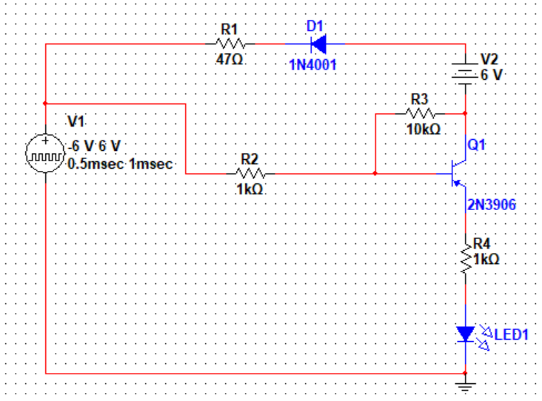

ON Circuit
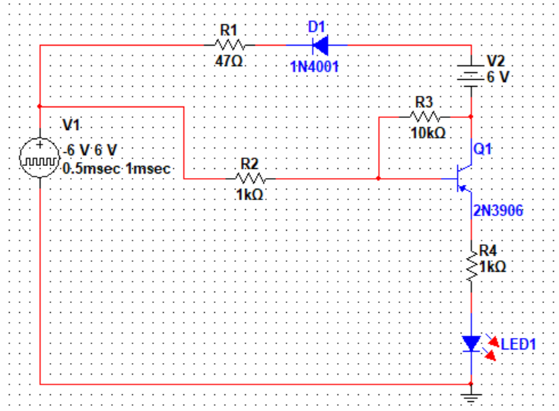

3. General Working Principle
- The circuit operates based on transistor switching using a PNP transistor.
- The emitter of the transistor is connected to the positive supply (+6V).
- The transistor turns ON when the base voltage is sufficiently lower than the emitter voltage.
Case 1: Input LOW (Negative Pulse)
- Base voltage becomes lower than emitter.
- PNP transistor turns ON.
- Current flows from emitter > collector > LED > ground.
- LED turns ON.
Case 2: Input HIGH (Positive Pulse)
- Base voltage becomes close to emitter voltage.
- Transistor turns OFF.
- No current flows through LED.
- LED remains OFF.
Role of Diode
- Ensures proper direction of current.
- Blocks unwanted reverse signals from affecting the circuit.

4. Truth Table

Input(V1) | Transistor State | LED OUTPUT
1(HIGH) | 0(OFF) | 0(OFF)
0(LOW) | 1(ON) | 1(ON))

5. Conclusion
This circuit demonstrates how a transistor can be used as a switch to control an output device remotely. The use of resistors ensures safe operation, while the diode adds protection and signal conditioning. The project helps in understanding practical applications of semiconductor devices in switching and control systems.

